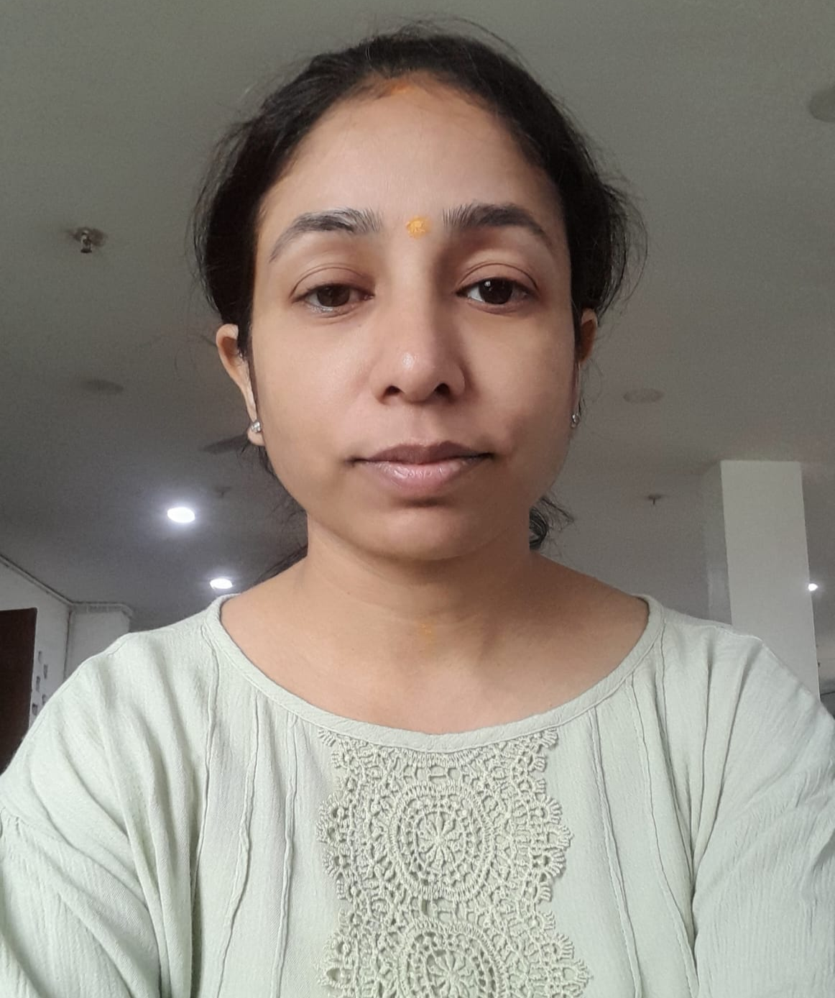 |  |  | SKILLS
CORE COMPETENCIES
• Search Engine Optimization (SEO)
• Technical SEO & Website Audits
• Digital Marketing Strategy
• Lead Generation & Brand Growth
• Google Analytics & Search Console
• Pay-Per-Click (PPC) Campaigns
• Keyword Research & Competitor Analysis
• Content Optimization & Marketing
• WordPress Website Development
• Social Media Optimization (SMO)
• Link Building & Guest Posting

• Performance Reporting & Analytics

RACHNA SEN  Profile |  |  | WORK EXPERIENCE
RACHNA SEN  Profile |  |  | Narayan Seva Sansthan- Sr. SEO Specialist (2023- 2026)  * Leading SEO strategy and execution for Narayan Seva Sansthan's digital platforms to increase organic visibility, engagement, and donations.  * Managing technical SEO audits, website optimization, indexing, crawlability, Core Web Vitals, schema implementation, and site performance improvements.  * Conducting keyword research, competitor analysis, and content planning for charity, donation, healthcare, disability support, and religious campaign initiatives.  * Optimizing multilingual content across English, Hindi, Gujarati, Marathi, Bengali, Telugu, Tamil, Malayalam, Punjabi, and other regional languages.  * Driving organic growth through on-page SEO, content optimization, internal linking strategies, and user experience enhancements.  * Monitoring and improving keyword rankings, organic traffic, and conversion performance using Google Analytics, Google Search Console, Ahrefs, and SEMrush.  * Collaborating with content, development, design, and marketing teams to ensure SEO best practices are implemented across all campaigns and website updates.  * Managing backlink acquisition, digital PR, and authority-building initiatives to strengthen domain performance.  * Optimizing content for AI-powered search experiences, including AI Overviews, Answer Engine Optimization (AEO), Generative Engine Optimization (GEO), and voice search.  * Supporting fundraising and awareness campaigns through data-driven SEO strategies that increase reach, visibility, and donor engagement.  Mumkins — Sr. SEO Specialist (2021 – 2023)  • Managed SEO projects that significantly improved website traffic and revenue.  • Conducted keyword research, competitor analysis, and advanced on-page optimization.  • Implemented off-page SEO strategies including guest posting and social bookmarking.  • Generated performance reports using Google Analytics and coordinated with product teams.  Advaiya Solutions — Digital Marketing Associate (2020 – 2021)  • Executed SMO and SMM campaigns to improve audience engagement and brand awareness.  • Developed and maintained WordPress and CMS-based websites.  • Worked on SEO, PPC, and conversion-focused digital marketing campaigns.  • Optimized website content and improved search engine rankings.  Yug Technology — Sr. SEO Specialist (2017 – 2019)  • Led SEO campaigns involving on-page and off-page optimization.  • Managed client projects and improved search engine rankings.  • Handled a team of 6–7 members and coordinated SEO execution.  • Implemented social media optimization strategies.
Results-driven Digital Marketing Professional with 8+ years of expertise in SEO, digital marketing strategy,
lead generation, website optimization, and online brand growth. Proven success in improving organic rankings, increasing website traffic, enhancing user engagement, and driving business revenue through
data-driven marketing strategies. Experienced in managing SEO campaigns, leading cross-functional teams, handling Google Ads campaigns, and implementing advanced SEO techniques across diverse industries.
Strong command over Google Analytics, Search Console, WordPress, content optimization, and performance marketing.

CONTACT

PHONE:
8302001653

EMAIL
og02insky@gmail.com

TOOLS & DIGITAL MARKETING EXPERTISE

SEO & Analytics Tools: Google Analytics, Google Search Console, Ahrefs, Ubersuggest, GTmetrix,
Google Trends, XML Sitemap Generator, SmallSEOTools.

SEO Expertise: On-Page SEO, Off-Page SEO, Technical SEO, Meta Tag Optimization, Link Building, Local
SEO, Website Performance Optimization, Content Strategy.

PPC & Campaign Management: Google Ads Campaign Creation, ROI Optimization, Conversion Tracking,
Campaign Performance Analysis.
 |  |  | EDUCATION
Master of Science (M.Sc.) — B.N.P.G. College, MLS University (73%)
• Bachelor of Science (B.Sc.) — B.N. Girls College, MLS University (69%)
• Diploma in Mass Communication & Journalism — Chennai Distance Education (70%)
• Online Diploma Course in SEO — Patna

